Effect of Airline Credit Card Loyalty Programs on Revenue for Airports
Overview
This project explores the relationship between airline credit card loyalty programs and the revenue performance of a small hub airport, with a focus on passenger Enplanements and Passenger Facility Charges (PFC) data. Airline credit card programs give points on customer spending that can lead to free or discounted flights for the credit card holders. This in turn could lead to a decreased amount of flight purchases with the airport/airlines.
This project uses historical airport enplanement and revenue data between the years of 2010-2024 of the Eugene airport to investigate the amount of passenger growth, non-revenue passengers, revenue dollars, and the amount of potential revenue loss caused by non-revenue passengers to determine if there is a noticeable impact caused by airline credit card loyalty programs or other related programs. A report of a unnamed medium sized airport is utilized to show the opposite results of the Eugene airport data.
Tools Utilized
Excel – Data cleaning, Formulas (non-revenue passenger ratios, non-passenger revenue loss, percentages of passengers, growth forecasting)
Analysis
From 2010 to 2024 the total amount of enplaned passengers grew from 378,373 to 838,645, which is a 222% increase. The number of non-revenue passengers grew from 9,636 to 14,360. This is a 149% increase.
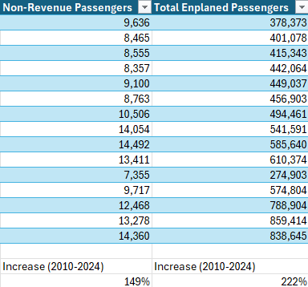
It was found that in 2010, 2.55% of all enplaned passengers were non-revenue passengers. This remained relatively constant through 2024. However, there was a small decrease down to 1.71% percent. Even though the total amount of non-revenue passengers increased, there was a systemic decrease in the overall picture. This was about a 67% decrease from 2010-2024.
This growth in non-revenue passengers, however small it may be, has led to a significant amount of lost revenue for the airport. Multiplying the amount of PFC for each year by the ratio of non-revenue passengers, we are able to extrapolate the amount of revenue that was lost. The total revenue lost from 2010-2024 was $635,688.72.
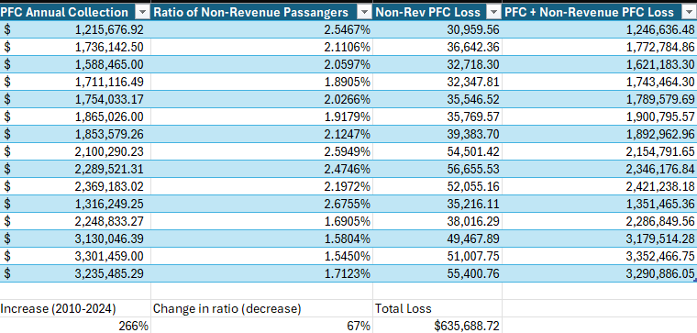
To understand this growth a little better, prepare for the coming years, and to show possible future revenue losses, I utilized forecasting tools within Excel to map out the next 5 years. The year 2020 is an outlier because of Covid-19, and slightly effects the R^2 value.
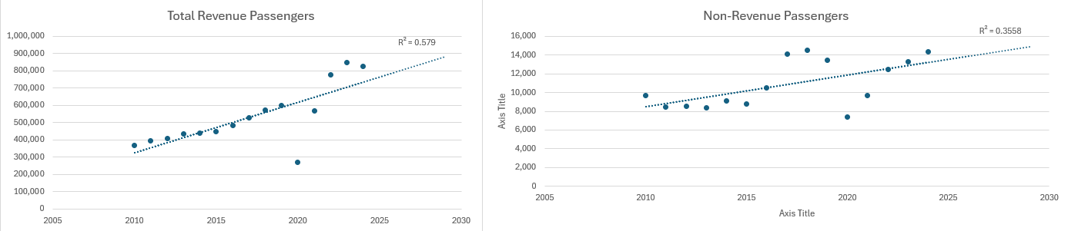
Comparison
This information comes from a medium hub airport. Names and locations are kept private.
Over the past decade, the rise of airline credit card loyalty programs and the widespread use of award tickets has fundamentally shifted how medium hub airports generate revenue. While these programs encourage repeat travel and increase passenger volumes, many travelers using points or rewards contribute little to no Passenger Facility Charges (PFCs) or federal excise taxes. As a result, a growing portion of airport traffic—estimated between 6–14%—does not directly fund the infrastructure these passengers rely on.
This shift has significant financial implications. Medium hub airports face growing revenue inefficiencies as non-revenue and award passengers increase, while infrastructure costs continue to rise. The loss of PFC revenue can compress debt service coverage ratios for airport bonds, potentially leading to higher borrowing costs and increased financial risk. Airports with higher concentrations of award-ticket traffic are particularly vulnerable, as the gap between passenger growth and revenue growth widens.
If left unaddressed, these trends could create a long-term funding gap for airport infrastructure, forcing airports to defer maintenance and expansion projects. Policy interventions, such as taxing untaxed ancillary fees, increasing PFC caps, or applying fees to award passengers, are necessary to ensure medium hub airports remain financially stable while continuing to accommodate growing passenger volumes.
Conclusion
In summary, with a smaller hub airport such as the Eugene airport, there seems to be no alarming increase in the rate credit card loyalty programs disrupting revenue. A decrease in the overall percentage of non-revenue passengers occurred in the 14 year period. There was only 1.71% of passengers being of the non-revenue type in 2024. The difference between small and medium sized airport hubs could be a difference in income. With higher income areas having an increased number of credit card loyalty points compared to lower income areas.
Looking ahead, the growing prevalence of award-ticket travelers poses ongoing financial challenges for medium/large hub airports. If these trends continue without intervention, airports may face long-term funding gaps that could impact maintenance and expansion projects. Implementing policies that address the revenue shortfall. Such as adjusting PFC caps or applying fees to award passengers, will be essential to maintaining financial stability while accommodating continued passenger growth. Overall, understanding the connection between loyalty programs and airport revenue is critical for sustainable planning and infrastructure funding.

